5.- Write a predicate last/2 which takes a list as its first argument and returns the last element of the list.

***lastElement(A,[A]).***

***lastElement(A,[_|B]) :- lastElement(A,B).***

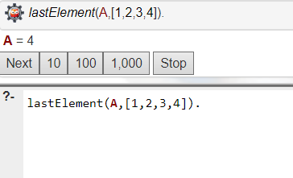

6.- Write a predicate split/4that splits a lis tintotwo parts, the length of the first part is given.

***splitList(A,0,[],A).***

***splitList([B|Bs],C,[B|Ds],Es) :- C > 0, C1 is C - 1, splitList(Bs,C1,Ds,Es).***

